**Question 7.1**

**Describe a situation or problem from your job, everyday life, current events, etc., for which exponential smoothing would be appropriate. What data would you need? Would you expect the value of alpha (the first smoothing parameter) to be closer to 0 or 1, and why?**

**Question 7.2**

**Using the 20 years of daily high temperature data for Atlanta (July through October) from Question 6.2, build and use an exponential smoothing model to help make a judgment of whether the unofficial end of summer has gotten later over the 20 years. (Part of the point of this assignment is for you to think about how you might use exponential smoothing to answer this question. Feel free to combine it with other models if you’d like to. There’s certainly more than one reasonable approach.)**

**Note: in R, you can use either HoltWinters (simpler to use) or the smooth package’s es function (harder to use, but more general). If you use es, the Holt-Winters model uses model=”AAM” in the function call (the first and second constants are used “A”dditively, and the third (seasonality) is used “M”ultiplicatively; the documentation doesn’t make that clear).**

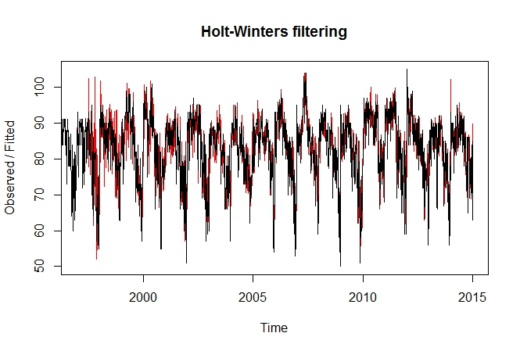I used the HoltWinters function, with seasonality, to apply the exponential smoothing to the data. The output of the function is shown in red while the original data is shown in black in Figure 1 below.

**Figure 1. Holt-Winters Plot**

Overall, we see a good fit on the data especially on later cycles. This is because as more data points are used to build the trends and seasonality components the model gets better at predicting the future results. It should be noted that the model doesn’t start until 1997, after it was able to process two cycles of data.

I then exported the models expected values, or the fitted values, to an Excel file and applied CUSUM to each year of the data. Using a C and T of 6 and 41, this removes all false flags earlier in the cycles and a very slight trend of summer ending later can be seen. As shown in Figure 2 below, it the summer end shifts from 29 SEP to 5 OCT. However, this is less than a 1 week difference and is probably well within the error of our calculations. This trend could also be due to fact the model gets better calibrated with every cycle, as mentioned above and shown in Figure 1. Therefore, it id plausible that no trend would be seen over this same time period if we were able to incorporate data from years prior to 1995.

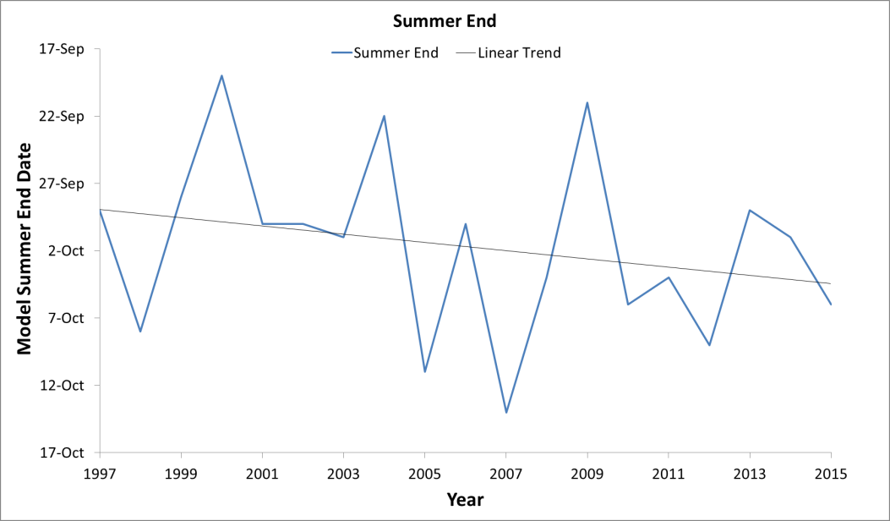

**Figure 2. Holt-Winters Plot**